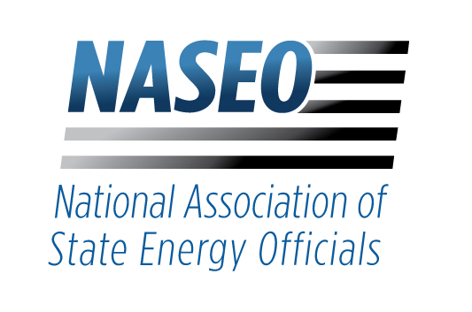
1300 North 17th Street
Suite 1275
Arlington, Virginia 22209
Telephone: 703.299.8800
www.naseo.org
BOARD OF DIRECTORS
Chair
ANDREW MCALLISTER
California
Vice Chair
KELLEY SMITH BURK
Florida
Treasurer
MOLLY CRIPPS
Tennessee
Secretary
JOHN WILLIAMS
New York
Past Chair
ROBERT JACKSON
Michigan
Parliamentarian
JASON LANCLOS
Louisiana
Regional Representatives
DAN BURGESS
Maine
PATRICK WOODCOCK
Massachusetts
DAVE ALTHOFF
Pennsylvania
MARY BETH TUNG
Maryland
MITCHELL SIMPSON
Arkansas
SUMESH ARORA
Mississippi
MICHELLE GRANSEE
Minnesota
CHAD KRUSE
Illinois
WILL TOOR
Colorado
JOE FRANCIS
Nebraska
MICHAEL FURZE
Washington
JOHN CHATBURN
Idaho
Affiliates' Co-Chairs
ELIZABETH BEARDSLEY
U.S. Green Buildings Council
MATTHEW MORRISSEY
Ørsted
Executive Director
DAVID TERRY
General Counsel
JEFFREY C. GENZER

Alfred M. Pollard
General Counsel
Federal Housing Finance Agency
400 Seventh Street SW, Eighth Floor
Washington, DC 20219

ATTENTION: ‘‘PACE Request for Input, Notice No. 2020–N–1.’’

Dear Mr. Pollard:

The National Association of State Energy Officials (NASEO) appreciates the opportunity to submit comments in response to the Federal Housing Finance Agency (FHFA) Notice No. 2020–N–1. NASEO represents the 56 governor-designated state and territory energy directors and their offices, and we welcome the opportunity to work with FHFA as you consider structures that promote consumer protections and risk management in residential Property Assessed Clean Energy (R-PACE) programs.

NASEO strongly believes that R-PACE should be available to state and local governments seeking to provide their constituents access to financing for projects that reduce energy consumption, costs, and greenhouse gas emissions. It is part of a range of programs that can assist homeowners who wish to make cost-effective energy efficiency improvements to their homes. NASEO’s State Energy Office members work extensively with bankers, energy efficiency companies, and others to provide financing products and incentives for the home energy efficiency market. Regardless of program structure, improvements in oversight, implementation, contractor engagement, and transparency can always be made to continue to protect borrowers.

The following comments pertain to Question 6 of FHFA’s RFI about the usefulness of a public registry that would include key PACE lending data points that would otherwise be difficult to access. Acknowledging the challenges faced by the Government-Sponsored Enterprises (Enterprises), mortgage lenders, and credit rating agencies in accessing reliable and consistent information about R-PACE-financed retrofits, NASEO believes that state-developed registries would increase transparency, consumer confidence, and ease of participation by various stakeholders in R-PACE programs.

The R-PACE registry concept is not new; however, it is nascent, and experience with operating a registry is limited. The registry under development in California may offer a valuable model for FHFA’s consideration. California AB 1284, enacted in 2017, requires R-PACE program administrators in California to develop and use a registry to track R-PACE loans in the state. Four major R-PACE financing providers, representing programs across hundreds of California communities, are building a registry for PACE loans. This registry will be developed using blockchain technology to ensure its security and will be accessible to the public. It will provide much needed transparency to the R-PACE market, and it will provide consumers with additional confidence when using R-PACE to finance energy retrofits to their properties.

California’s approach offers an example for other states to adapt if they decide to enable R-PACE. However, NASEO believes each state should determine the specific contours of its R-PACE registry. To the extent that FHFA is interested in participating in discussions with the State Energy Offices on R-PACE registry best practices, NASEO would be pleased to work with FHFA to organize these discussions.

NASEO also welcomes the opportunity to work more generally with FHFA and the Enterprises to continue to improve the quality, safety, and energy performance of the nation's building stock across the nation. Beyond PACE, the State Energy Offices can offer significant expertise and insight to inform other types of investments and financing products that support residential energy efficiency retrofits. NASEO invites FHFA to collaborate with the states on this matter in order to expand and improve the set of tools available to homeowners. Not only would a collaborative approach create consistency across state and local markets, but it would also spur economic activity and address the pressing challenges of climate change, housing affordability, and public health.

Thank you for your consideration and the opportunity to provide comments. If you would like to discuss this issue further, please contact me at dterry@naseo.org.

Best regards,


David Terry
Executive Director
National Association of State Energy Officials

