R. Scott Woods, CPA
President / CEO

January 15, 2015

VIA EMAIL TO REGCOMMENTS@FHFA.GOV

Alfred M. Pollard, Esq., General Counsel
Attention: Comments/RIN 2590-AA39
Federal Housing Finance Agency
400 Seventh Street SW, Eighth Floor
Washington, D.C. 20024

RE: Notice of Rulemaking and Request for Comments – Members of Federal Home Loan Banks (RIN 2590-AA39)

Dear Mr. Pollard:

South Carolina Federal Credit Union appreciates the opportunity to comment on the Federal Housing Finance Agency’s (FHFA) notice of proposed rulemaking and request for comments on “Members of the Federal Home Loan Banks” published on September 12, 2014. The proposed rule reviews current statutory and regulatory provisions governing Federal Home Loan Bank (FHLBank) membership, proposes regulatory changes to the eligibility requirements for membership, and invites comments on all aspects of the rule.
South Carolina Federal Credit Union is a $1.3 billion institution located in Charleston, South Carolina and serving the communities (counties) of Charleston, Dorchester, Berkeley, Orangeburg, Georgetown, Calhoun, and most of Lexington and Richland. We are a member of FHLBank Atlanta and one of nearly 1,000 financial institutions serving communities in the Southeast in a variety of ways.
We are concerned about the potential negative impacts of the proposed rule and request that the FHFA withdraw it. If the FHFA believes changes are still needed, we would encourage the FHFA to conduct a series of public hearings to determine the best way to achieve them. Further, since the proposed rule appears to conflict with past Congressional actions regarding FHLBank membership and access to liquidity, we believe the FHFA should consult with Congress to ensure that any proposed changes are consistent with Congressional intent.

While the proposed rule may or may not have a significant immediate impact on the majority of FHLBank members, it could negatively affect our access to a reliable source of liquidity, particularly during periods of market stress as occurred during the 2007-2008 financial crisis. By imposing ongoing, rigid, quantitative asset-based tests, the proposed rule could limit our flexibility to manage our business in response to changing market conditions. As an FHLBank member, we already must comply with a number of requirements that ensure our use of FHLBank funding is consistent with the FHLBank System’s housing and community lending mission. Chief among these requirements is the mission-centric collateral used to secure our borrowings from FHLBank Atlanta.

In addition, we are concerned that the proposed rule sets the precedent of a regulator effectively amending current law. The proposed rule does not recognize the actions of Congress over the last 25 years to expand FHLBank membership, mission, and members’ access to liquidity. The rule, without Congressional action or approval, effectively amends those statutory provisions, reversing and shrinking FHLBank membership, mission, and access to liquidity. This sets a precedent that could pave the way for additional limitations in the future, including more restrictive asset tests for members, further changes to the definition of an FHLBank member, or the imposition of size limits for FHLBank members.

Again, we request that the proposed rule be withdrawn and that the FHFA instead engage in a series of public hearings to solicit a variety of viewpoints and alternatives to the rule from diverse stakeholders that may be impacted by this wide-ranging proposal.

We greatly appreciate your consideration of these comments.
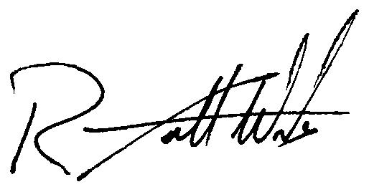
Sincerely,

R. Scott Woods, CPA
President and CEO
South Carolina Federal Credit Union

