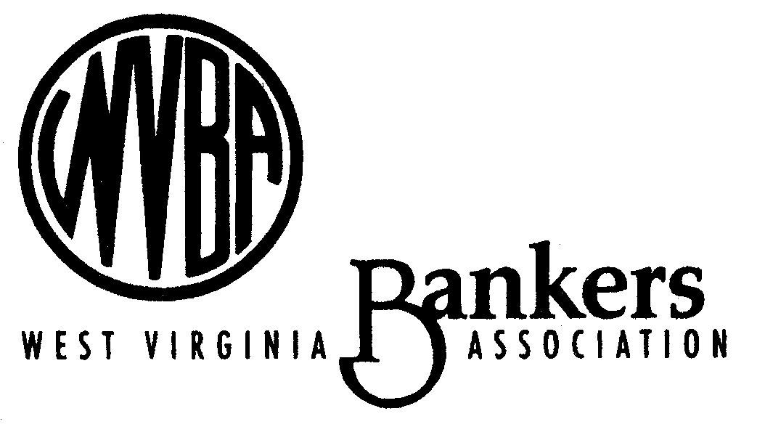
120 Washington Street, E
Charleston, WV 25301
January 6, 2015
Alfred M. Pollard, General Counsel
Attention: Comments/RIN 2590–AA39
Federal Housing Finance Agency
400 Seventh Street SW, Eighth Floor
Washington, D.C. 20024
Re: Notice of Proposed Rulemaking and Request for Comments – Members of Federal Home Loan Banks (RIN 2590–AA39)
Mr. Pollard:

The West Virginia Bankers Association represents banks that serve the credit and lending needs of homebuyers, small businesses, consumers and communities throughout West Virginia. Many of our members are also members of the FHLBank Pittsburgh. As noted in this letter, we are concerned by that the proposed regulation would impose new regulatory burdens on our members, and potentially put our member banks at odds with their regulators, all to address a problem that does not exist.

Enactment of this rule will impose new burdens on individual banks that are already successfully managing their credit, liquidity and interest rate risk. In 1989, Congress established membership in an FHLBank was contingent upon a 10 percent asset test for membership but without an ongoing test. Imposing an ongoing mortgage asset test that has no basis or need is a disincentive to banks – its adds another layer to regulatory hurdles they already clear. Additionally, imposing an ongoing housing asset test disregards a bank’s direct home mortgage lending activity in making mortgages to their customers which are then sold in the secondary market.

The regulation could also place bankers in a contradictory position with their own regulator. Bank regulators are concerned about regulated entities increasing interest rate risk and may be encouraging banks to hold fewer long-term mortgages on their balance sheet. This is particularly important as markets and regulators are expecting rates to rise above current historically low rates. The proposed rule could lead to encourage banks to keep long-term, fixed rate mortgage assets to meet the asset test to retain FHLBank membership. Financial institutions rely upon FHLBank Pittsburgh as a provider for their lending needs as well as managing liquidity risk. Bank regulators are directing their regulatees to continually manage liquidity risk and, as the potential for expulsion from the FHLBank is raised, bank regulators may require bankers to seek replacement sources of liquidity.

The problem intended to be solved by this proposed regulation is not apparent. WV Bankers Association members stuck with FHLBank Pittsburgh during tough times, which supports the FHFA concerns that FHLBanks remain well-capitalized. Now that FHLBank Pittsburgh is profitable, members who have been loyal may be forced out.

Oversight responsibilities placed on FHLBanks by the proposed rule are troubling. Belonging to FHLBank Pittsburgh makes a bank an owner (as a member of the cooperative). It is inappropriate to place the FHLBank Pittsburgh in a de facto regulatory role over their owners.

The FHLBanks have successfully served their membership and mission for over 80 years. Adding regulatory burdens that are unnecessary, in conflict with existing regulatory guidance of bank regulators and inconsistent make this an ill-advised proposal. We strongly request the Finance Agency withdraw RIN 2590–AA39.

Sincerely,

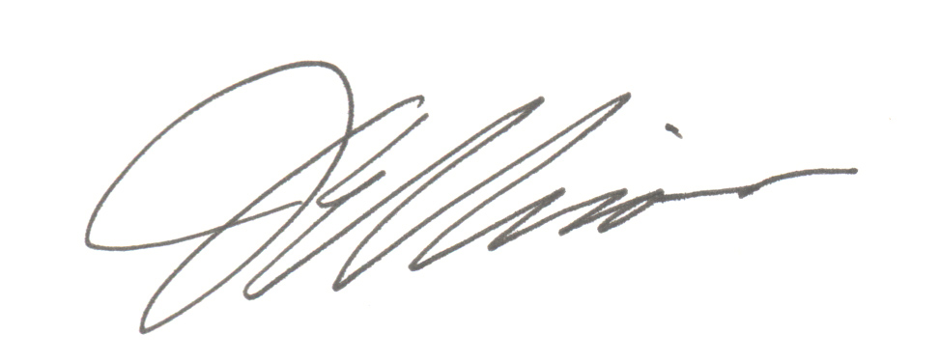

Joe Ellison
President and CEO
West Virginia Bankers Association

