December 16, 2014

Alfred M. Pollard, General Counsel

Attention: Comments/RIN 2590–AA39

Federal Housing Finance Agency

400 Seventh Street SW

Washington, D.C. 20024

Re: Notice of Proposed Rulemaking and Request for Comments – Members of FHLBanks (RIN 2590–AA39)

Dear Mr. Pollard:

Our organization has utilized FHLBank Topeka’s Affordable Housing Program (AHP) to serve the affordable housing needs of our community. Our clients have benefited greatly from the funding made available from AHP, and we view FHLBank Topeka as a valuable affordable housing partner. We’re deeply troubled that the Federal Housing Finance Agency’s (FHFA) recently issued proposed rule impacting FHLBank membership could diminish the funding available through FHLBank Topeka’s AHP.

The proposed rule would require members of FHLBank Topeka to jump through a number of additional, unnecessary hoops in order to maintain their membership in the FHLBank cooperative. As many as 107 of FHLBank Topeka’s 791 member institutions could lose their membership in the FHLBank under the proposed rule. Fewer banks, thrifts, credit unions and insurance companies borrowing from FHLBank Topeka would almost certainly result in a decrease in FHLBank lending volume. It follows logically that this would lead to a reduction in FHLBank profitability. And a decline in FHLBank Topeka’s profitability will have a correspondingly negative impact on the amount of funding available through AHP.

FHLBank Topeka estimates that as much as $510,000 of its annual contribution to AHP could be lost if FHFA’s proposed rule were fully implemented. In FHLBank Topeka’s district alone, this would translate into 68 fewer down-payment-assistance grants per year for moderate-income home buyers. Considered another way, FHFA’s proposed rule could result in 92 fewer affordable rental units available annually for underserved individuals in our region. Programs such as Habitat for Humanity could see 127 fewer units subsidized per year as a direct result of the proposed rule. We highly doubt this is the outcome FHFA seeks from its proposed rule. However, these could be the real-world implications if the full rule takes effect.

As you know, FHLBank Topeka also offers a grant program separate from AHP known as Joint Opportunities for Building Success (JOBS). The JOBS program is designed to promote economic development initiatives that assist member institutions in promoting employment growth in their communities. FHLBank Topeka contributes up to $1 million annually to JOBS. It’s possible, although not

necessarily likely, that funding for the JOBS program could be at risk if FHFA’s proposed rule is fully implemented. Such an outcome would further exacerbate the economic hardships many in our community are facing.

We live in a time when funding sources for affordable housing in America are shrinking. Because of that, the last thing our nation needs is an unnecessary hit to a highly successful grant program which, for the past 25 years, has been tremendously successful by nearly every measure. We strongly encourage FHFA to consider the families and the communities that will be negatively impacted by your proposed rule. Without a compelling safety and soundness concern – or a clear direction from Congress – we believe FHFA’s proposed rule is unnecessary. We respectfully request that FHFA withdraw the proposed rule immediately.

Sincerely,

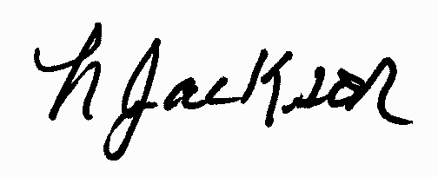

Lisa Jackson

President/CEO