October 16, 2014

Alfred Pollard, General Counsel
Federal Housing Agency
400 Seventh St. SW, 8th Floor
Washington, DC 20024

RE: Comments/RIN 2590-AA39 – Notice of Proposed Rulemaking – Members of FHLB Banks

Dear Mr. Pollard,

Thank you for allowing comments on the Proposed Rulemaking regarding membership of FHLB Banks.
After reviewing the proposal, I ask you to rescind the rulemaking as the current membership rules for the FHLB appear to be working well.

Islanders Bank is a community bank headquartered in Friday Harbor, Washington and does currently meet all the requirements for the ongoing 1% and 10% requirement in the proposal; however, many community banks around the country may not meet these test elements but are worthy of the benefits of FHLB membership.

Community banks have few options for liquidity and bank services that are as comprehensive, capable and economical as the FHLB Banks. The FHLB Banks provide a very important service to the community banking industry and community banks provide very important services to “main street” businesses through the United States. The diversity of membership of the current FHLB Banks is diverse and strong, limiting the membership would likely be counterproductive and bad for the “main street” economy.

Unlike many of the other Government Sponsored Enterprises, such as FNMA, Farm Credit and Freddie Mac, the FHLB has chosen to partner and serve community banks and credit unions rather than compete with them while using the inherent advantage that government sponsorship entails.

I’m a strong believer in the FHLB Banks and feel that the current rules of membership provide a good base of support for their operations. I definitely understand the intent of the proposed regulation and appreciate the reasoning behind it; however, don’t feel that the change is warranted at this time.

Thank you for the opportunity to comment on this issue.

Sincerely,
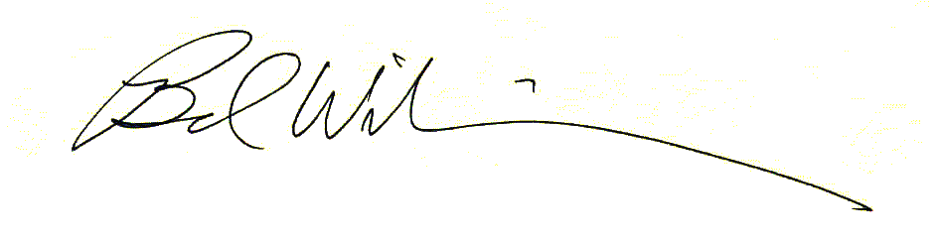
Brad Williamson
President and C.E.O.

