7/28/2026

Alfred M. Pollard, General Counsel
Attention: Comments/RIN 2590–AA39
Federal Housing Finance Agency
400 Seventh Street SW
Washington, D.C. 20024

Re: Notice of Proposed Rulemaking and Request for Comments – Members of FHLBanks (RIN 2590–AA39)

Dear Mr. Pollard:

​I am writing to express very serious reservations about the notice of proposed rulemaking regarding membership eligibility in Federal Home Loan Banks (FHLBanks), that the Federal Housing Finance Agency (FHFA) recently issued. The proposed rule includes significant changes to long-standing membership rules for the FHLBank system, including credit unions.

As an aggregator of credit union mortgage lending, Members Mortgage Services see's first-hand the value the current MPF program provides to its member institution. We would like to see more credit unions access this program. Our country is slowly recovering from a recession that had roots in the mortgage industry. This rule throws unneeded road-blocks to homeownership and increases the administrative costs of sustaining a mortgage program at the time when greater access to credit is so needed to sustain the recovery. It also seems punitive to a system that didn't require a government bail-out, because of it's structured soundness.

On behalf of the 28 credit union's who own us, we feel that in reducing access to our FHLBank, the credit available to communities in our region will be unnecessarily impacted. We believe this proposed rule is a solution in search of a problem. In light of the implications of this deeply flawed proposed rule on credit unions and the local communities they serve, we ask you to withdraw this flawed proposed rule.

​Sincerely,
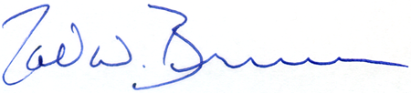

Todd W. Brunner
President/CEO

