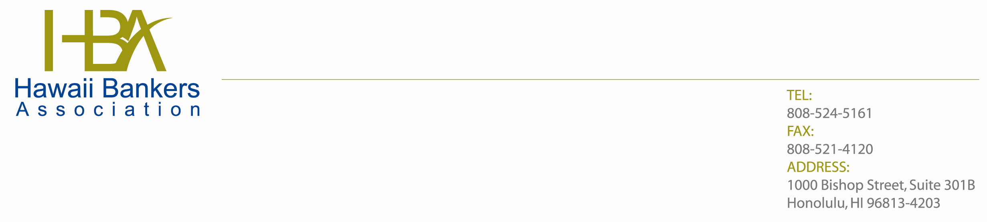
October 2, 2014

The Honorable Melvin L. Watt, Director
Federal Housing Finance Agency
400 7th Street, SW
Washington, DC 20024

SUBJECT: RIN 2590-AA39

Dear Director Watt:

Thank you for the opportunity to provide comments on the recently issued proposed rulemaking regarding membership eligibility in Federal home Loan Banks. We are concerned the proposed new FHLBank membership requirements will adversely impact many existing and prospective FHLBank members and, more importantly, the communities they serve.

First of all, there does not seem to be any compelling reasons to impose these new membership rules. Historically, Congress has defined FHLBank membership criteria, and the existing criteria has been effective since it was created in 1989. And, they have periodically reviewed and revised the membership rules to assure it continues to meet its objectives. We do not believe the proposed changes by the FHFA at this time are necessary and it will likely have a detrimental effect on the communities that member banks serve.

The banks in Hawaii have regarded the FHLBank system as a critical source of liquidity, as well as an important conduit to the secondary markets. As you know, community financial institutions play a vital role in funding housing, job growth, and economic development in the communities we serve. This is especially important for a geographically isolated area like Hawaii. Restricting our access to the FHLBank system will definitely hurt our economy.

In summary, we urge you to withdraw this proposal and instead establish a dialogue with Congress, where these important policy decisions currently reside.

Sincerely,

Edward Y. W. Pei
Executive Vice President

