December 8, 2011

Mr. Edward DeMarco
Acting Director
Federal Housing Finance Agency
1700 G Street, NW, 4th Floor
Washington, DC 20552

Submission to: Servicing_Comp_Public_Comments@FHFA.gov

The undersigned thank the Federal Housing Finance Agency (FHFA) for the opportunity to comment on its “Alternative Mortgage Servicing Discussion Paper,” released on September 27, 2011. The world of servicing has undergone unprecedented stress over the course of the economic downturn. We therefore appreciate the interest of FHFA and other regulators in ensuring that we collectively work to improve service to borrowers, reduce financial risk to servicers, ensure flexibility for guarantors to better manage non-performing loans, promote market liquidity and enhance opportunities for competition in the origination as well as servicing markets.

However, we believe that any change to the current servicing compensation model is unnecessary to accomplish these goals. The current system has served the market well for decades and still remains a viable option, even in these tumultuous times. Furthermore, any consideration of changing mortgage servicing compensation is premature in light of the ongoing process of developing national servicing standards, in addition to the constantly changing regulatory environment due to the implementation of the Dodd-Frank Wall Street Reform and Consumer Protection Act (Dodd-Frank).

While we do not endorse a change to the current servicing compensation model, we do recognize that there is a feeling amongst the regulators that there is a need for change. If FHFA feels strongly that making fundamental changes to the servicing fee structure is necessary, of the options presented in the September 27th discussion paper, we urge FHFA to adopt the cash reserve model. Of the two proposals presented, it is the only one which truly meets FHFA’s stated objective while ensuring minimal disruptions to the market.
The Cash Reserve Proposal, originally introduced by MBA and the Clearinghouse, establishes a minimum “normal servicing fee” and proposes the creation of a reserve account which servicers can use to conduct catastrophic nonperforming loan servicing. The reserve would be built up over time by placing a small portion of the mortgage cash flow (e.g., 3 bps) into a custodial reserve account, tied to a particular vintage of loans. Any unused portions would eventually be refunded to the mortgage servicer if they are not required to cover unanticipated operating costs of the servicer. Under this structure, use of the reserves should be the exception, not the rule, and would not be expected to occur under normal market conditions.
We believe that this approach is the best of the options presented, though we would reiterate: the fact remains that despite the issues in the mortgage servicing market and the need for investment and training in servicing, the current mortgage servicing compensation structure is appropriate and suitable to meet the needs of the market.

Thank you for your consideration of our comments.

Sincerely,

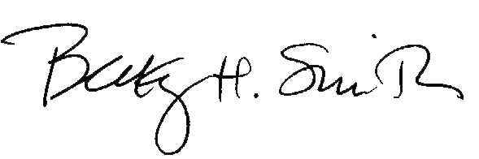
Becky H. Smith
Senior Loan Officer
Megastar Financial
1080 Cherokee St.
Denver, CO 80205
303-733-4510
bsmith@megastarfinancial.com

